Cycle Registration – Material Selection

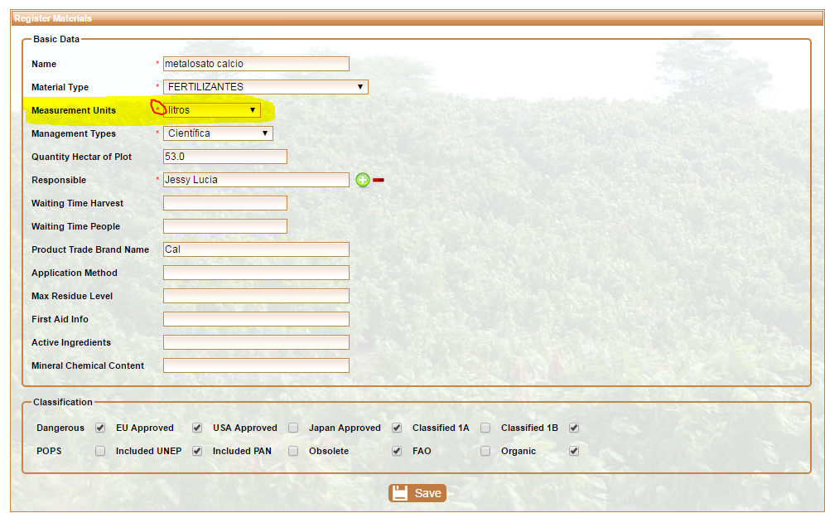

Measurement Units is required field in Material registration thus making selection of such unnecessary when quantities are specified for Cycle Registration.( see highlighted field in the screen shot above)

Please, make units auto-appear when material is selected in Cycle Registration Form:

